PMP ATP Bootcamp FAQ
Topic | Section
How to join the session via Percipio? | Registering and Joining the Live Sessions
Is live attendance required? | Bootcamp Attendance Rules
How to communicate in the Zoom sessions? | Chat and Q&A Panels in Zoom
How to join audio in zoom? | Joining Audio and Editing Audio Settings in Zoom
How to access the session recordings? | Watching Session Recordings
How to access Percipio resources? | Accessing Percipio Resources
How to access SharePoint and GitHub resources? | Accessing SharePoint and Resources
How to obtain the PMI-ACP Learner Kit? | PMI-ACP Learner Kit
How to obtain your certificate of completion for the PMI-ACP Bootcamp? | Accessing Completion Certificates

Registering and Joining the Live Sessions
Before you can join a PMI-ACP Bootcamp live session, you must first register for the bootcamp. To register, you need to log in to your Percipio account and navigate to the Live Course page of the bootcamp. To quickly locate the Live Course page, enter “PMI-ACP” in the search field on your Percipio training site and then filter by Live Course. Click on the PMI-ACP Bootcamp title to access the Live Course page.
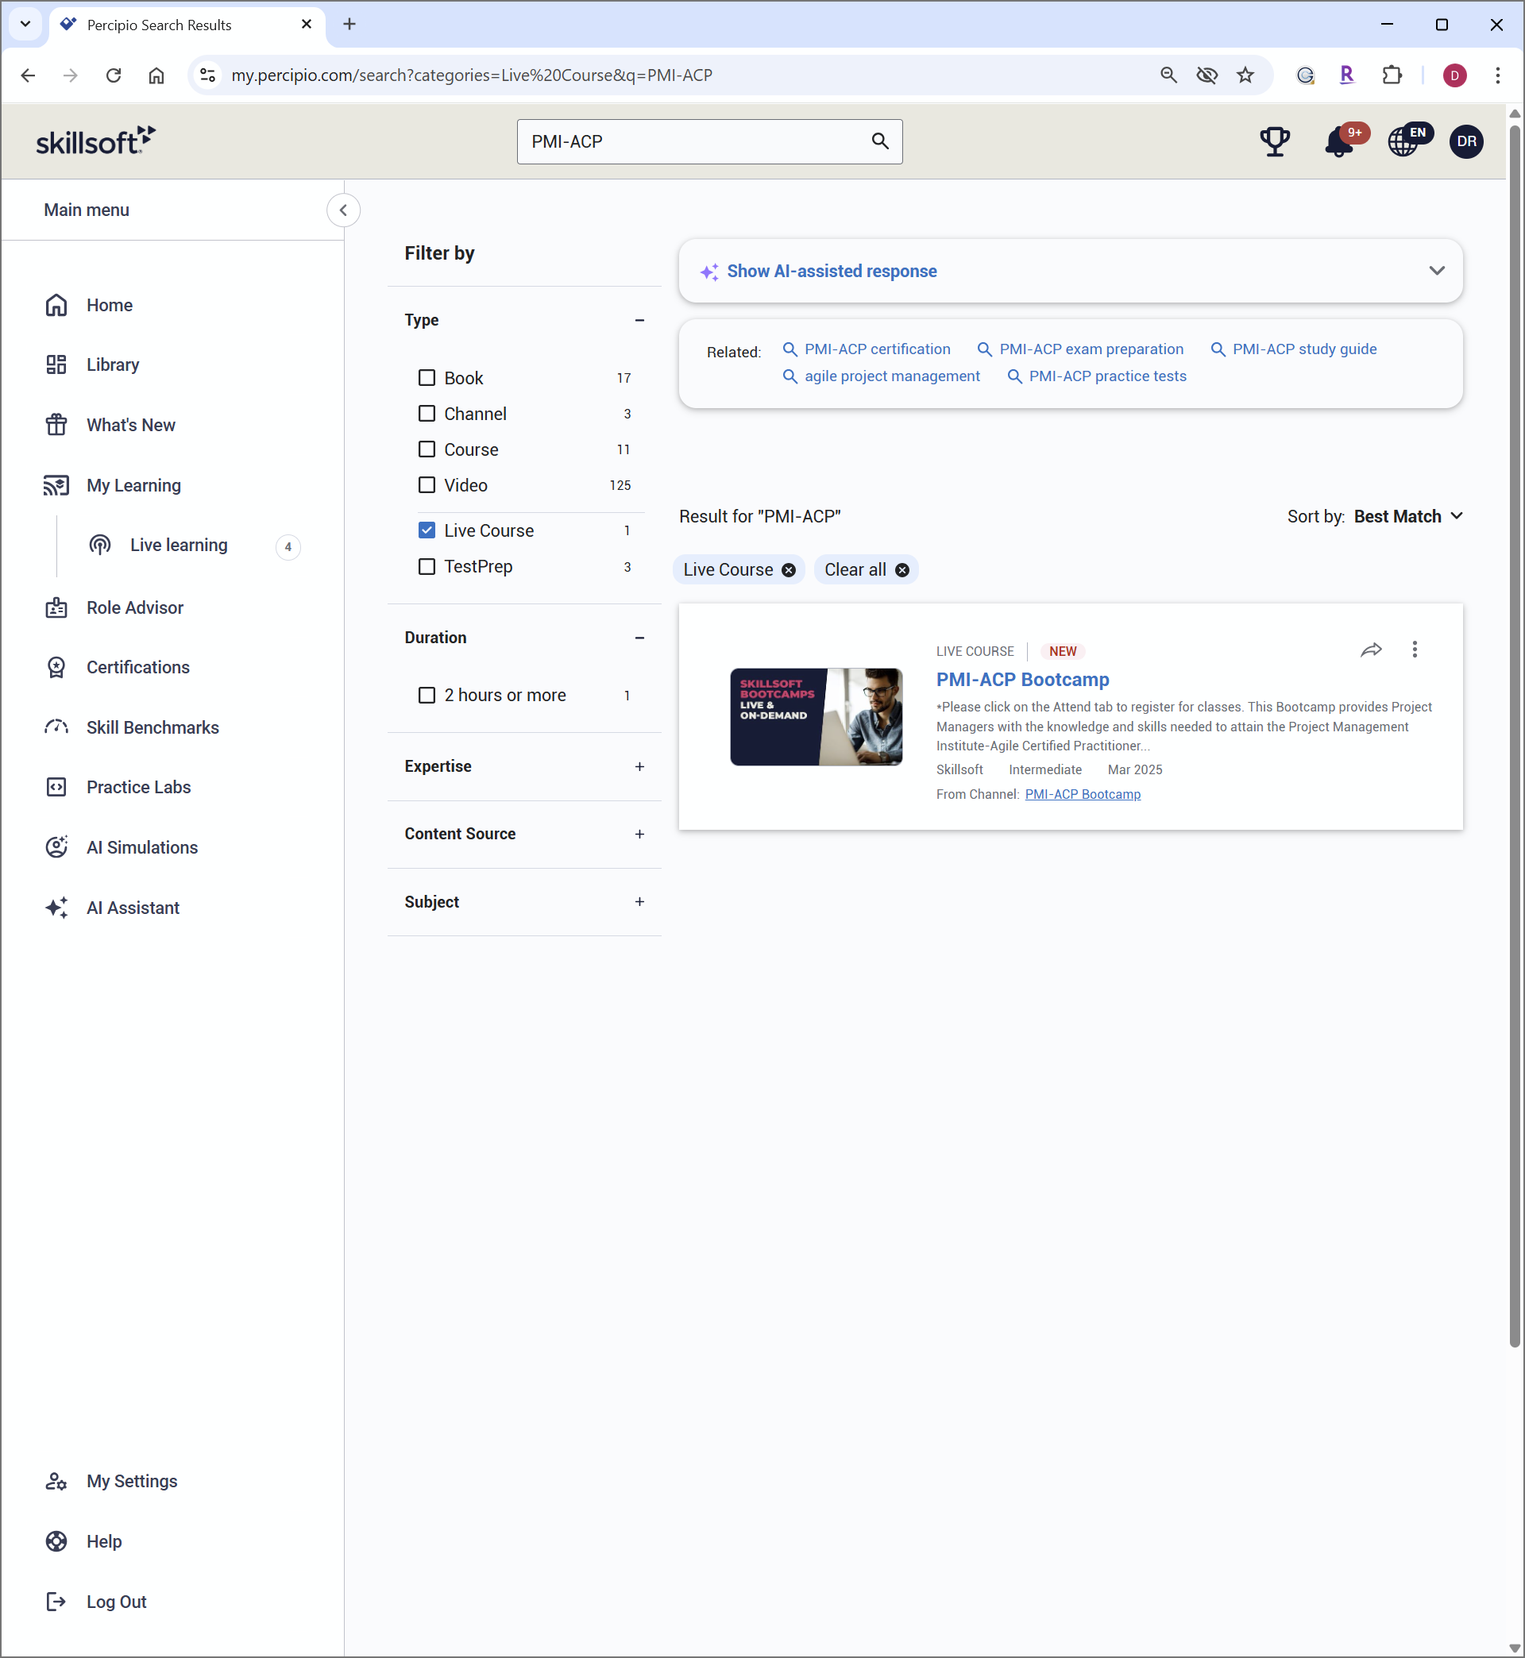

From the Live Course page, you will see a list of upcoming classes that includes the dates and times for your locale. To join a cohort, click on the Register button associated with that cohort. Please be aware that you can only unregister for a cohort prior to the start of the first session.
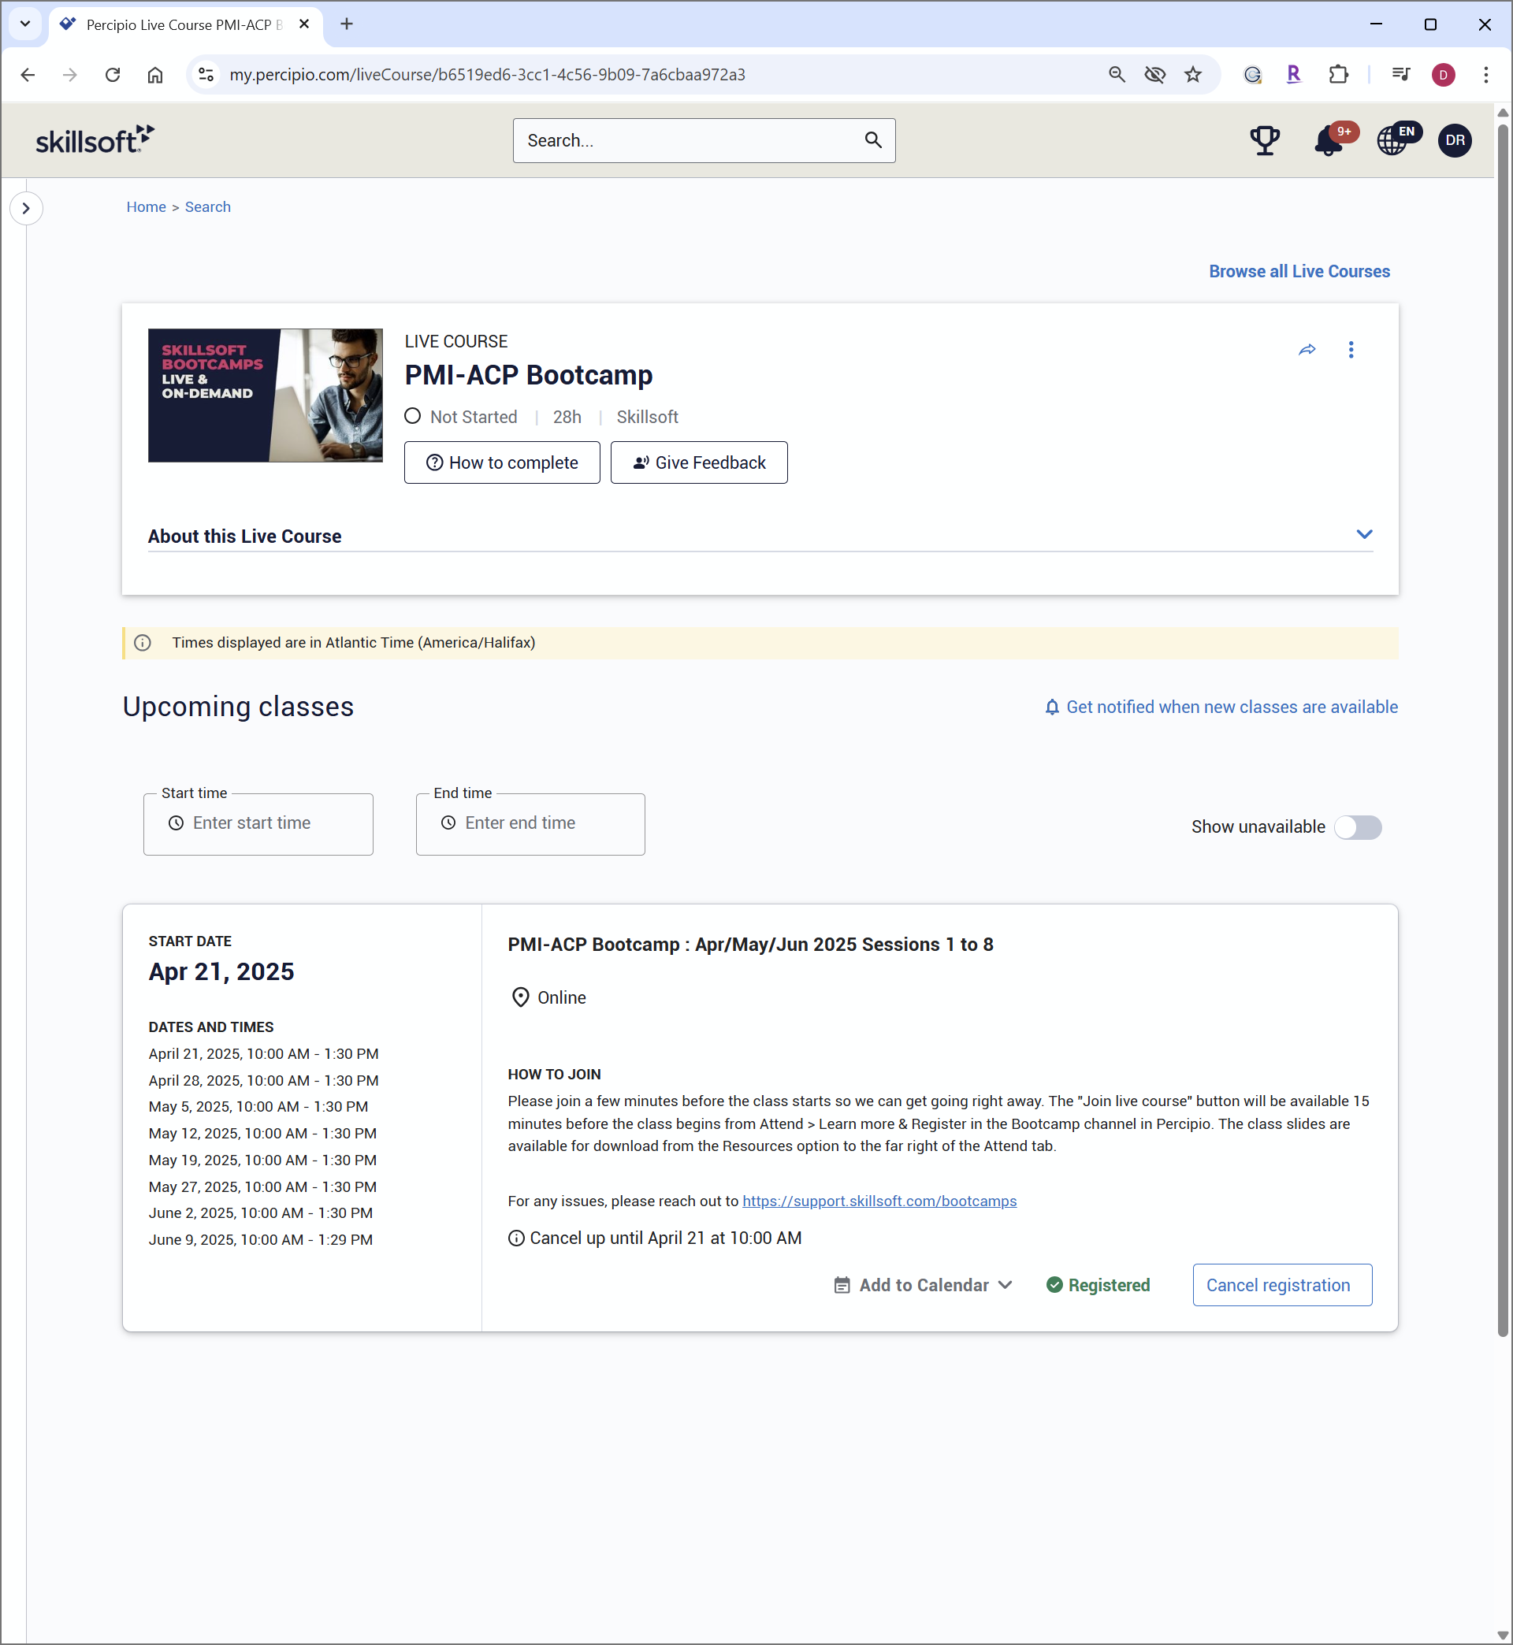
To join a live session via Percipio after you have registered, log in to your Percipio account and navigate to the Live Course page of the PMI-ACP Bootcamp. Approximately 15 minutes prior to the start time of the live class, you will see a Join live session link for the cohort you are registered for. We highly recommend joining early to test your audio and video prior to the start of the session and to ask any questions that you may have. Clicking on this link will open the Zoom session in your browser.

Bootcamp Attendance Rules
PMI requires that attendees of PMI ATP training attend the sessions live; however, you are allowed to replace up to two live sessions with the recordings and still qualify for the certificate of completion at the end of the bootcamp. If you miss more than two live sessions, you will need to attend the equivalent session in a future PMI-ACP Bootcamp cohort for any subsequent missed sessions. Please note that any session where you miss more than 15 minutes is considered a missed session.
Please be aware that time is automatically tracked by Zoom as soon as you join a live session. If you are joining the session from your Percipio training site, Percipio is also tracking your time. You do not have access to the backend of these systems to see what was specifically recorded for you and we are not able to verify your attendance for a session during the bootcamp. I can assure you that if you are in the session, your time will be recorded.
As a result, we recommended that ALL attendees download and maintain the PMI-ACP Attendance Tracking document to track any missed time in a session to ensure you are aware if you miss more than 15 minutes in a session, as that is considered a missed session. The PMI-ACP Attendance Tracking document can be downloaded from the Resources drop-down menu of the PMI-ACP Bootcamp channel in Percipio or from our GitHub and SharePoint site.

Chat and Q&A Panels in Zoom
All attendee’s microphones and cameras are disabled by default in the Zoom sessions. To communicate with the instructor, bootcamp admins, and fellow attendees, you can use the Chat and Q&A panels within Zoom. To access either of these panels, click on the Chat and Q&A icons at the bottom of the Zoom window.
Please use the Q&A panel to ask questions concerning the content being presented and questions about the bootcamp, as it will allow us to track the questions and ensure that your question is addressed. You should also post in the Q&A panel if you are having technical issues with the bootcamp. If you post questions or technical issues in the Chat, they may be missed as the Chat tends to scroll quickly due to the large number of attendees in these sessions.
Please use the Chat panel to interact with your fellow attendees and the instructor. For instance, if the instructor asks for attendee feedback on a particular topic or the answer to a question, the Chat panel is where you should post your answers. During breaks, you can also post in the Chat panel if you want to share your social media information or want to organize study groups with fellow attendees. If you want everyone to see your post, please set the To field in the Chat panel to: 'Everyone'.
NOTE: The Chat panel can be disruptive to some attendees during live instruction, so we may choose to pause the chat during these times, which will prevent attendees from posting. It will be opened to Everyone whenever the instructor requires your feedback and during breaks.
For those that are bothered by the notifications from new posts to the Chat panel, disabling chat previews may be helpful. To disable chat previews in Zoom, from the Chat panel, click on the three dots at the top right of the chat window and select "Disable Chat Preview". This will prevent chat messages from popping up on your screen during the meeting.

Joining Audio and Editing Audio Settings in Zoom
When joining a live session, the Zoom audio may not be enabled by default. If you do not hear the instructor or audio in the session, you need to click on the "Join Audio" icon at the bottom left of the Zoom window. You can choose to join with computer audio or by phone. If you are joining computer audio, you can test your speakers from the pop-up window by selecting the “Test speaker and microphone” option. If you want to join audio by phone, you need to dial the number and enter the meeting ID and password provided by Zoom from the "Phone call" tab.
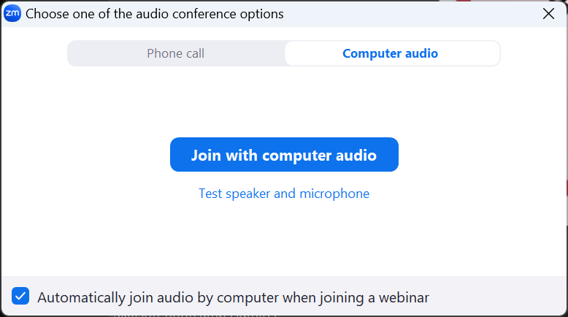
If you are joined to audio, you will see an Audio icon in the bottom left of the Zoom window instead of the "Join Audio" icon. To edit audio settings in Zoom, you need to click on the arrow next to the "Audio" icon. There you can access the audio settings menu, where you can adjust your microphone and speaker volume, mute or unmute yourself, and switch to a different audio device.

Watching Session Recordings
Please be aware that the sessions will be recorded; however, due to restrictions imposed by the Project Management Institute (PMI), we are not able to upload and host the session recordings in Percipio. The recordings can only be streamed from the Zoom servers using the recording links and passcodes that we provide to the attendees of the cohort. Here is the process for obtaining the recording links:
- Open the following link to our GitHub repository: https://github.com/Skillsoft-Content/PMI-ACP-Replay
- Click on the PMP-ACP Replay Zoom Links 2025 file and then click the Download icon on the right-hand side of the window. This icon includes a downward pointing arrow.
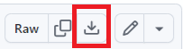
- Open the Excel file from your local machine. When the file opens, and you will be prompted enter a password. The following password is case sensitive and includes zeros ‘0’, not the capital letter ‘O’: acpB00tcampReplay!
- Select the worksheet for your cohort from the tabs at the bottom of the workbook. The link and passcode for each recording will be included in the worksheet.
The first time you access a recording; you will be presented with a registration page that you must complete. Please use the same first and last name that you are using in the live Zoom sessions.
NOTE: Attendees will have access to the recordings for one year from the date that the session was presented live, and they can access the recordings as many times as they like during that period.

Accessing Percipio Resources
To access Percipio resources, you need to log in to your Percipio account and navigate to the Channel page of your cohort. To quickly locate the Channel page, enter “” in the search field on your Percipio training site and then filter by Channel. Select your cohort from the results of your search. Click on the PMI-ACP Bootcamp title to access the Channel page.
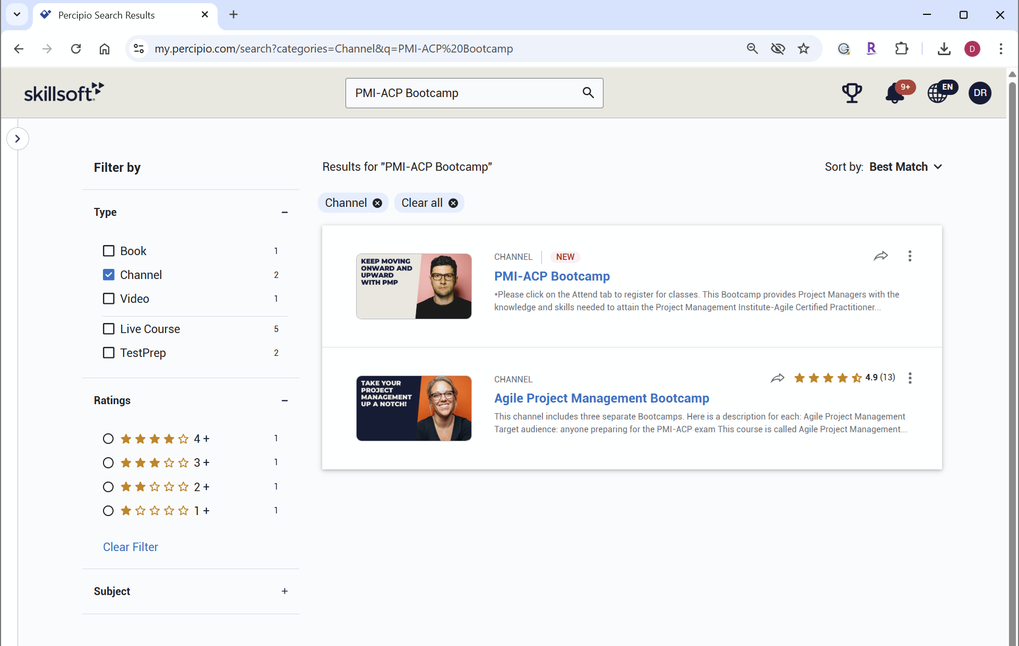
On the Channel page for your cohort, you should see various tabs such as Read, Practice, and Attend. The Read tab will contain online books that are helpful in preparing for the PMI-ACP exam, such as the Agile Practice Guide. Please be aware that not all organizations subscribe to our online books, so if you do not see a Read tab, you may not have access to books. The Practice tab contains our practice exam, and the Attend tab will lead you to the Live Course page where you can register and joint the live bootcamp sessions.
You should also see a Resources drop-down menu to the right of the tabs. Clicking on this menu will provide a list of documents that are associated with the bootcamp that you can download. We recommend downloading the class slide decks and the Attendance Tracker document prior to the start of the bootcamp.
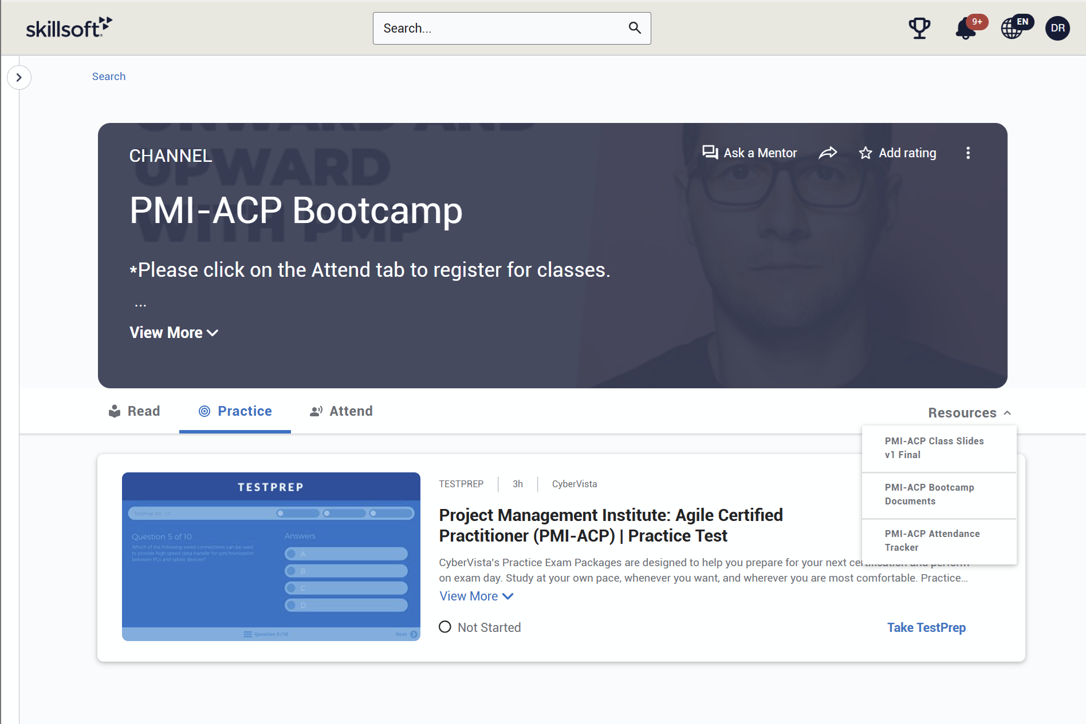

Accessing SharePoint and GitHub Resources
For those not on a Percipio training site, we provide a GitHub repository and a SharePoint site to access the resources associated with the bootcamp. Here are the links to those sites for your reference. The resources on these sites should be available to attendees for approximately one year.
GitHub:
https://github.com/Skillsoft-Content/PMI-ACP
SharePoint URL:
https://skillsoft.sharepoint.com/:f:/s/LiveBootcamp/EtWaQV7fQx9KiSq4KabHB3QBYWCB8B79ozRp4BJHV_6oag?e=MZhg2a
If you are downloading the bootcamp resources from GitHub, I would recommend downloading the full repository by clicking on the green Code button and then selecting Download ZIP. After downloading the ZIP file, you will want to right-click the file you downloaded and then select Extract All.
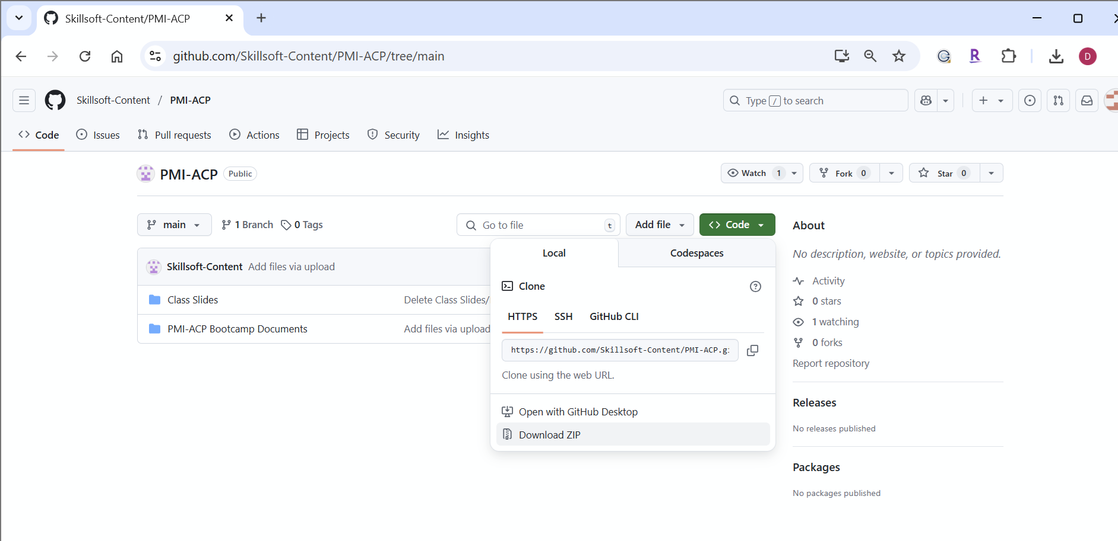

PMI-ACP Learner Kit
Please note that attendees who intend to use the PMI-ACP Bootcamp to meet the 28 hours of training in agile practices, frameworks, and methodologies requirement on their PMI-ACP application must have the PMI-ACP Learner Kit prior to submitting their application to PMI. This is a PMI requirement that is part of the Authorized Training Partner (ATP) agreement between Skillsoft, which is an ATP, and PMI.
The PMI-ACP Learner Kit must be purchased through Skillsoft and redeemed through PMI. Please contact your corporate training staff to see if they will be providing you with the Learner Kit. If your organization isn't providing it for you, you can purchase the PMI-ACP Learner Kit using the following URL. Please use the email address associated with your PMI account when purchasing the kit.
https://www.skillsoft.com/pmp-voucher-offering
**NOTE: The PMI-ACP Learner Kit is not yet available for purchase but should be available soon.
The process for purchasing and accessing your PMI-ACP Learner Kit is provided in the PMI-ACP Learner Kit Instructions.pdf, which can be downloaded from GitHub, SharePoint, and the PMI-ACP bootcamp channel in Percipio.

Accessing Completion Certificates
If you attend all eight sessions fully from Percipio, you should be able to generate your own certificate from your Percipio account after the last session and will not need to upload your PMI-ACP Attendance Tracker document. If you miss a session or join via the Zoom app or link and do not maintain a connection from Percipio, you will need to send a request to our Certificate Processing department to get your certificate at the end of the bootcamp. As part of the request process, you will be given the option to upload your PMI-ACP Attendance Tracker document.
To access a completion certificate in Percipio, you need to log into your Percipio account and navigate to the Certificate Certificates page of your profile. You can access this page by clicking on your profile icon in the upper right-hand corner of the Percipio window and then selecting My Learning. In the Accomplishments section, click on Completion certificates. You can also access My Learning from Main menu by clicking on the Site Navigation button in the upper left-hand corner of the Percipio window.
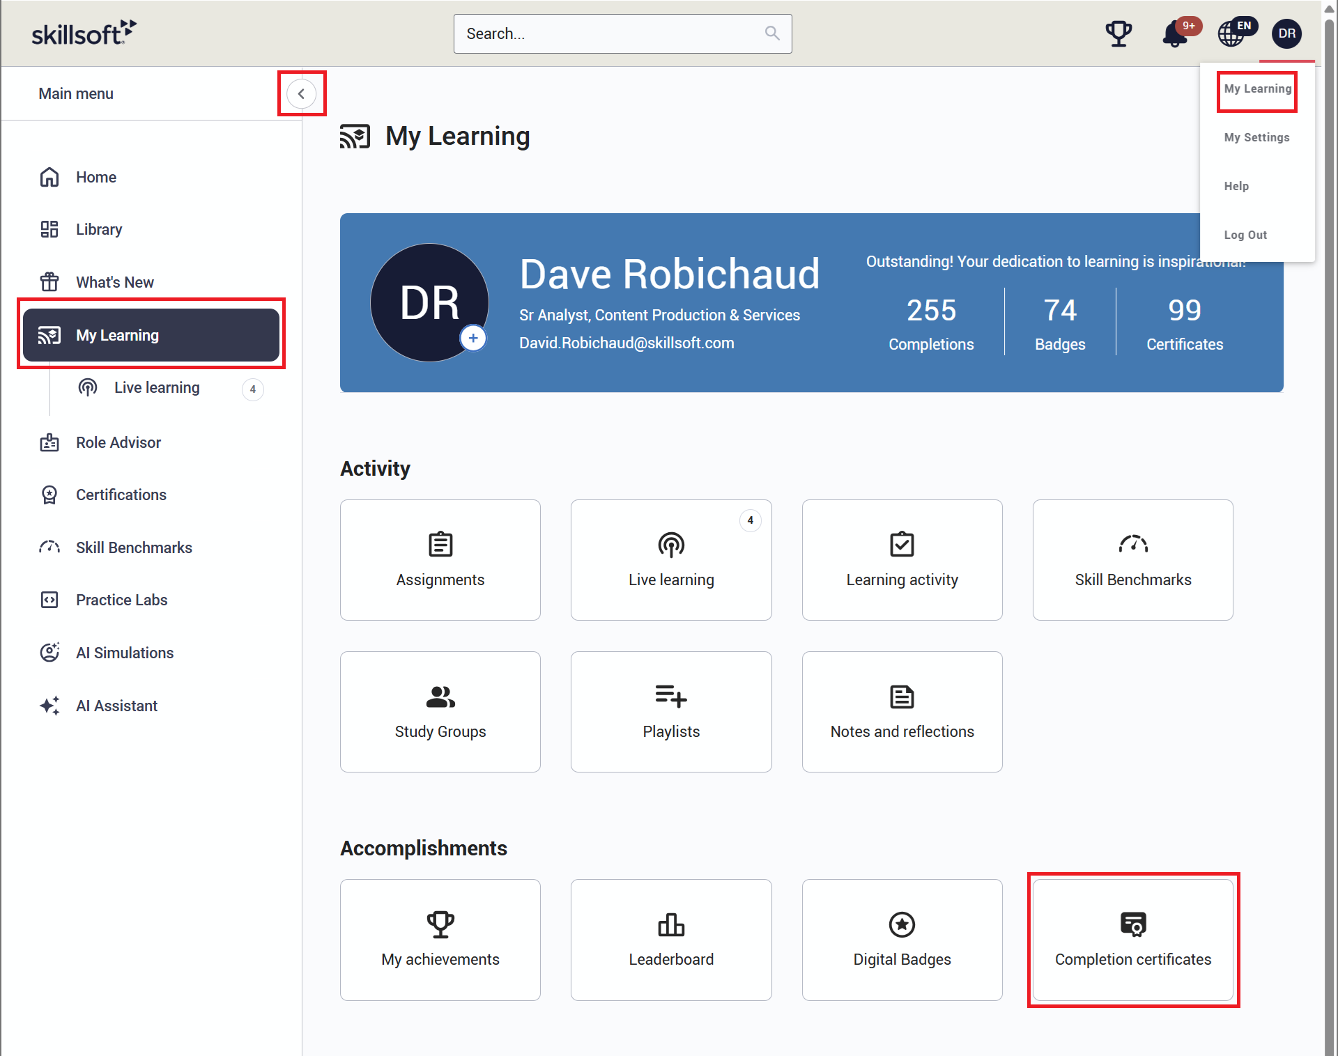
The Completion Certificates page will open to the Standard completion certificate by default. To get an official PMI certificate of completion, you will need to switch to the PMI PDU tab near the top of the page.
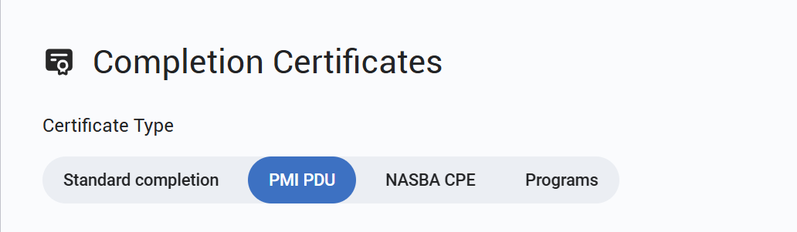
If you are not able to access certificates on your Percipio training site using the above steps or your course is not marked as complete at the end of the bootcamp, I would recommend contacting your organization’s training coordinator/administrator directly for assistance, as they have access to your account and are better able to assist you in this situation.
If you require any further assistance, you can contact Customer Support via e-mail at support@Skillsoft.com, or please feel free to reach out to them using one of our Live Help options 24 hours a day, 7 days a week! You can access our live chat or a complete list of our phone numbers at http://support.skillsoft.com.
If you missed a session or did not participate fully from a Percipio training site, you will need to access the certificate request website (https://certificaterequest.skillsoft.com) and fill out the online form to receive your completion certificate. You need to provide your name, email, course name, course ID, and completion date. You also need to upload your PMI-ACP Attendance Tracker document as part of the process. After submitting your request, you will then receive a confirmation email and should receive your completion certificate within 12 to 14 days. You can find a step-by-step guide on how to obtain your completion certificate from the Certificate Processing department in the PMI-ACP Attendance Tracker document.

